

Enterprise Standards and Best Practices For IT Infrastructure.
Sri Lanka Institute of Information Technology.

4th Year Second Semester.

Name: Dahami Y.H.N

Student ID: IT13107710

- Log in to the vmware vSphere Client to do the vmware vsphere migration. Go to the

Configuration tab and click on Network Adapters.
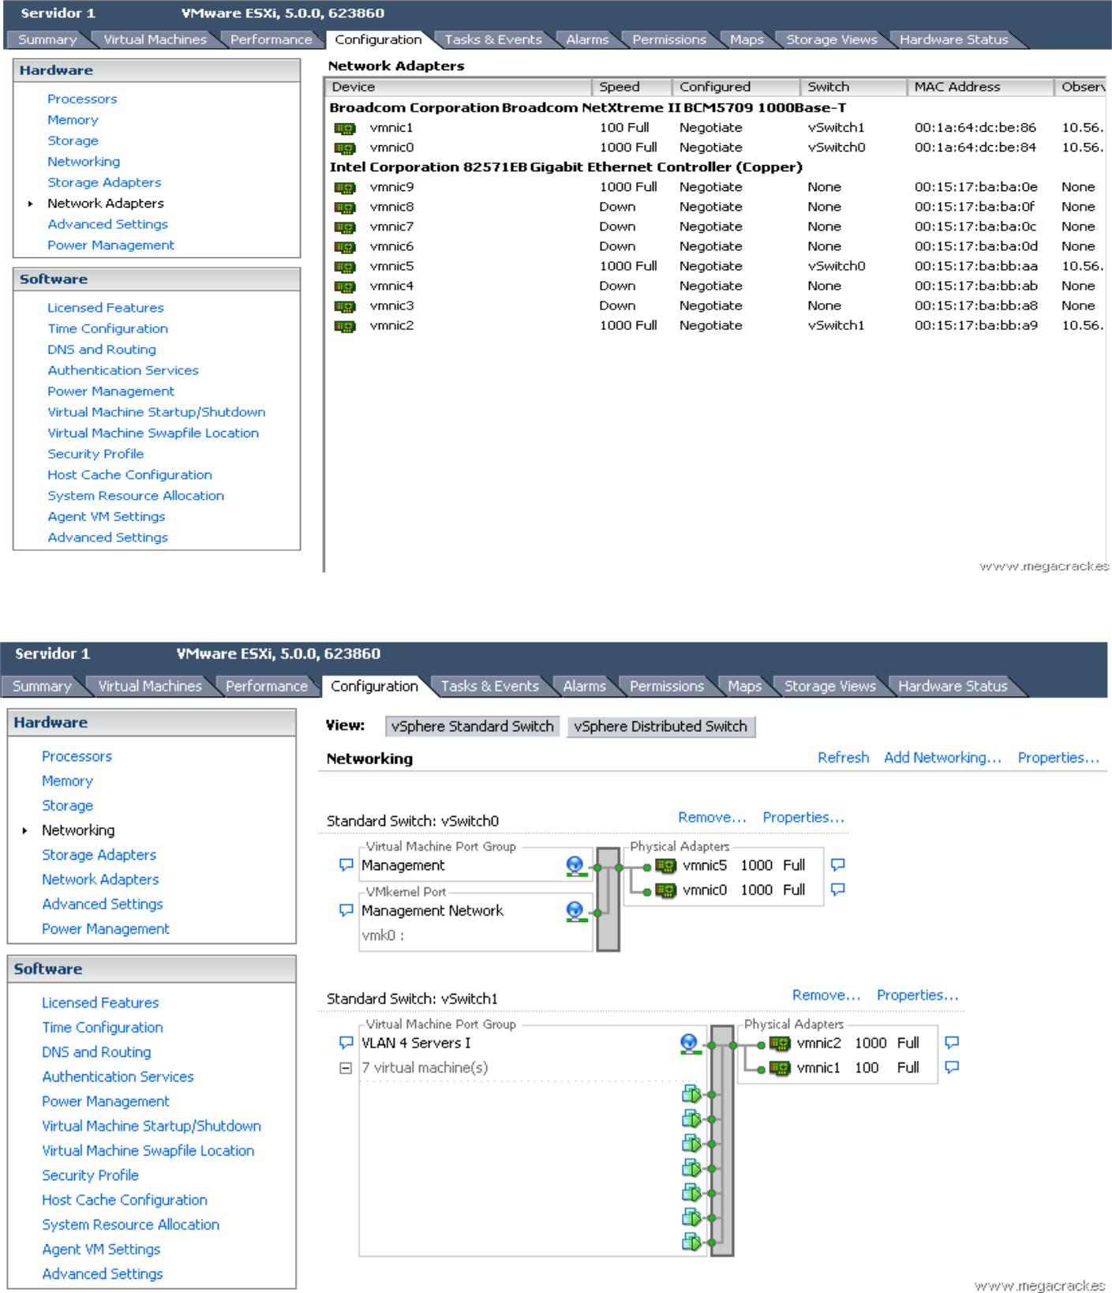

- Now click on Add Networking to create the vSwitch. Select connection type as VMKernel in the Add network Wizard. then click Next.
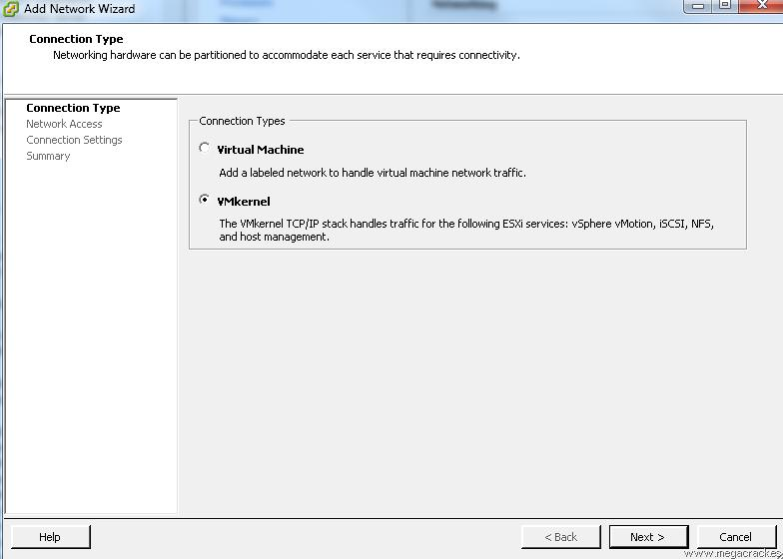

3) After appearing this window then click next button. Do not change any default selection.
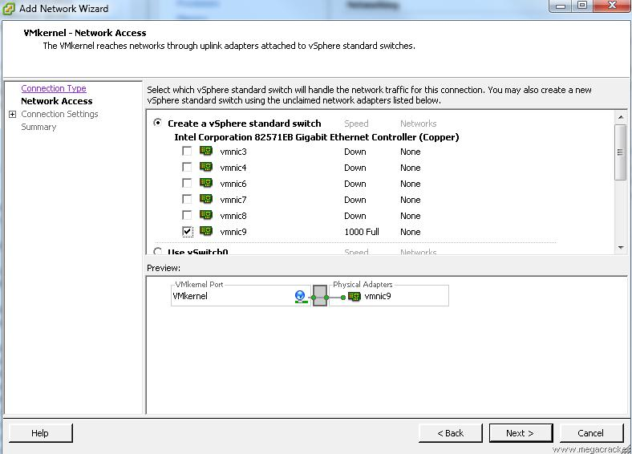

- Making a network card or cards that have connected from one server to another (in our case vmnic9) And click on Next (give the network label as vMotion. And select the first option as the VLAN ID. This is key step of the scenario. After doing that click next button.)
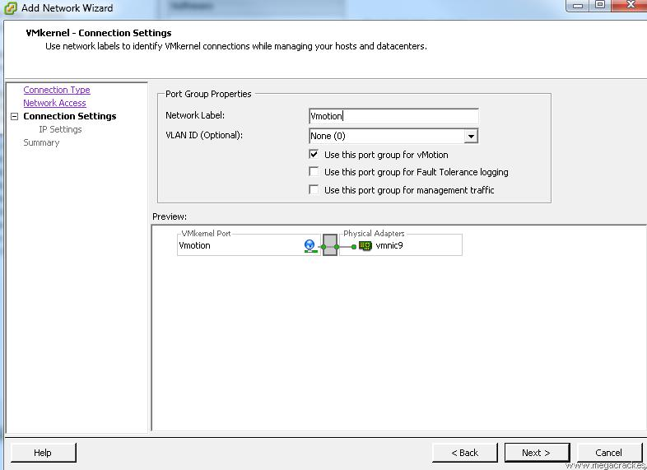
5) We set Use this port group for vMotion.

We wrote a Label Network different if you want (optional) and click on Next. We for example we put Vmotion. we have to give unique,

ip address – 50.50.50.1 Subnet Mask – 255.255.255.0
Then click on Next.
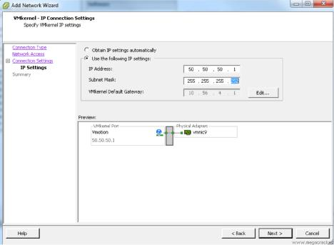

6) Click on Finish button.
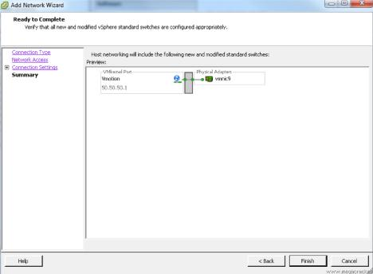

7) Do the same procedure starting from step1 to step 7 to the exsi02.
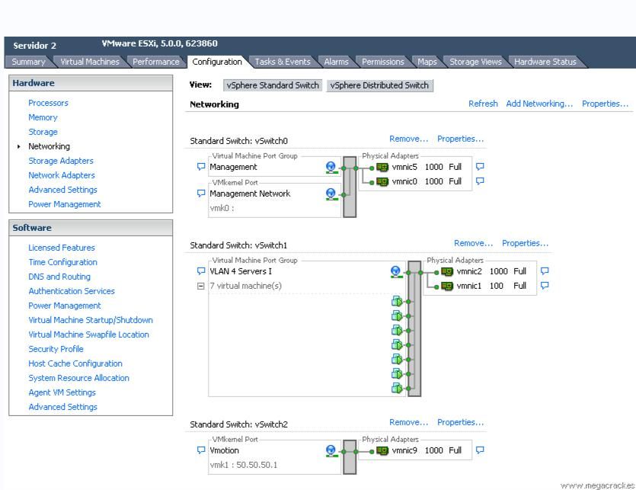
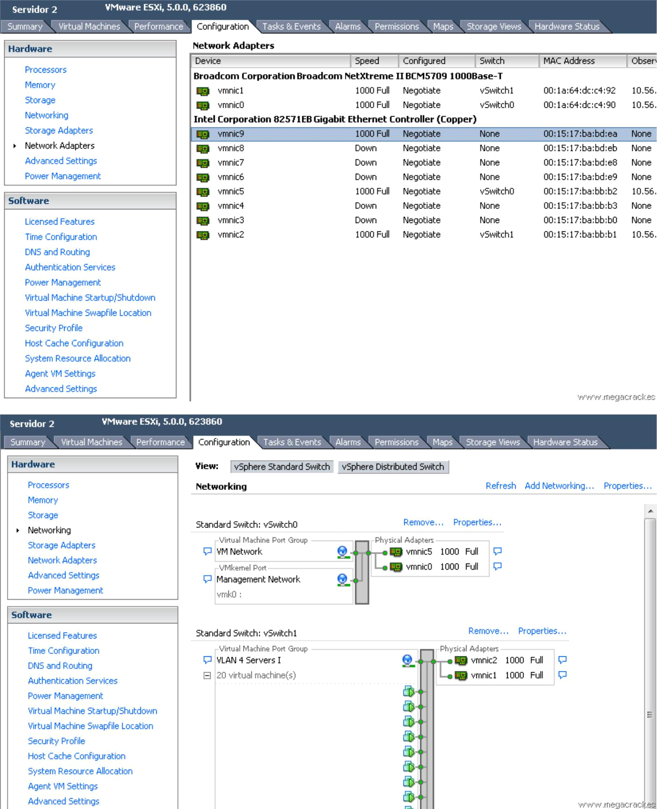
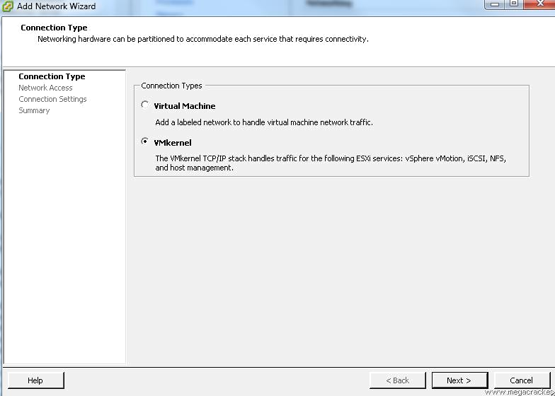

- Making a network card or cards that have connected from one server to another (in our case vmnic9) And click on Next.
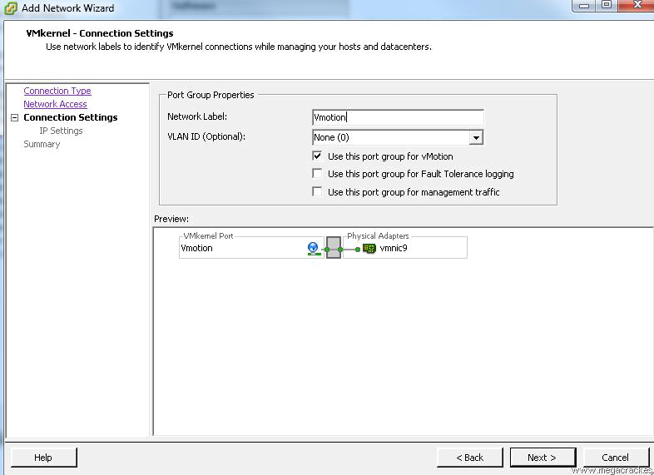

9) We set Use the following IP settings:

IP Address: 50.50.50.2 (This ip must be different from the server that we configured earlier.

Subnet Mask: 255.255.255.252 (Since we will use only 2 ip's).

Click on Next.
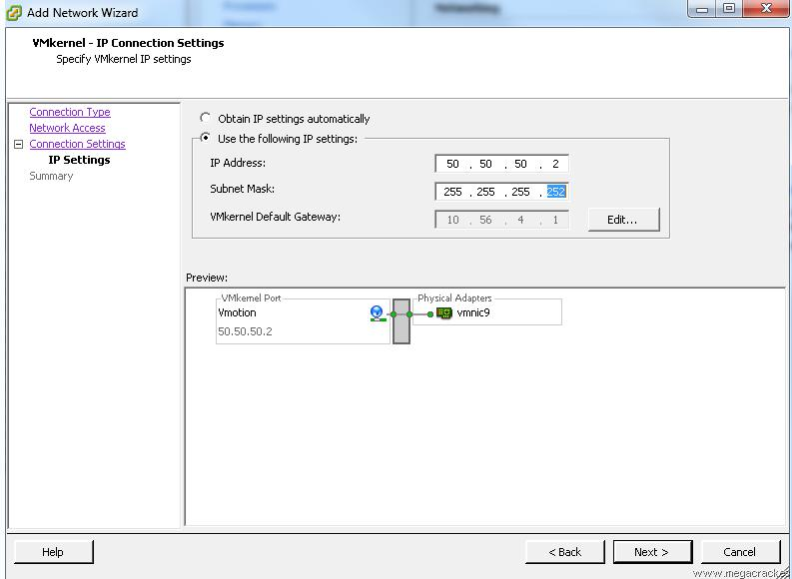
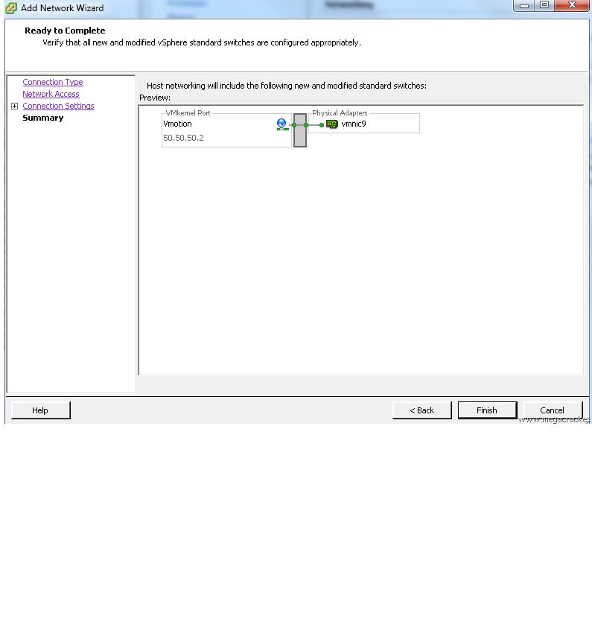

Click on Finish.

- To ensure that the entire system is working properly migrate a VM from one ESXi to the other using Vmotion functionality you just configured.
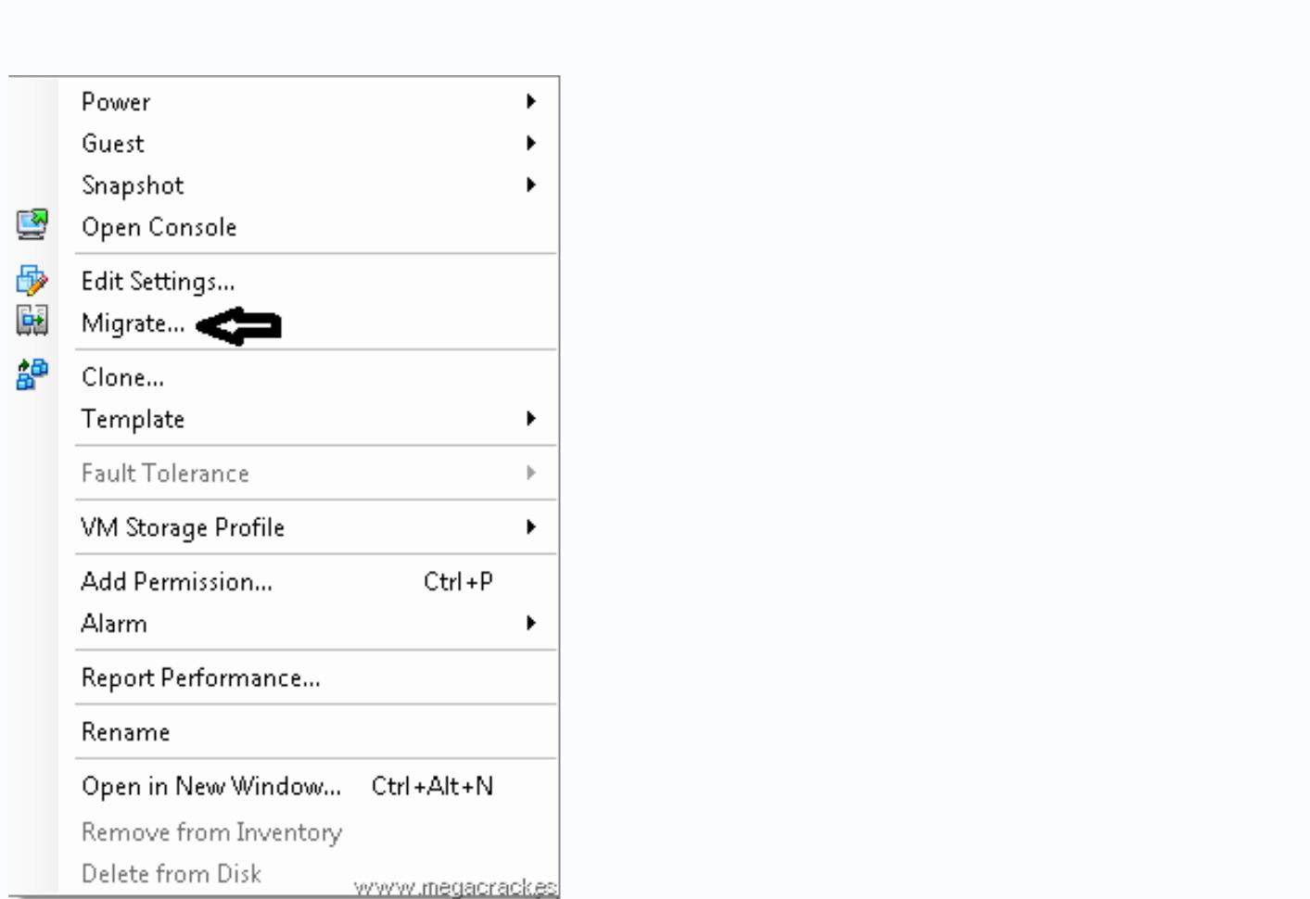
Press the right mouse button on a virtual machine

11) Click on Migrate
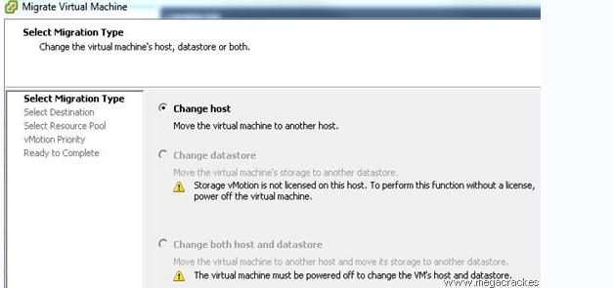
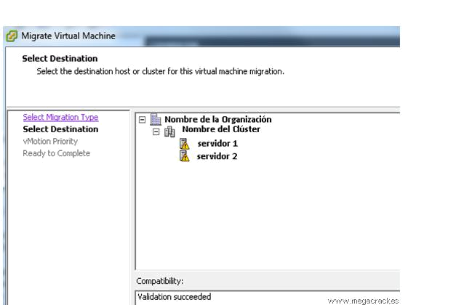
Click on Next

12) Select the target server where we will move the virtual machine. Click on Next
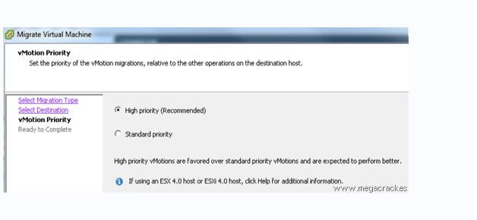

Click on Next

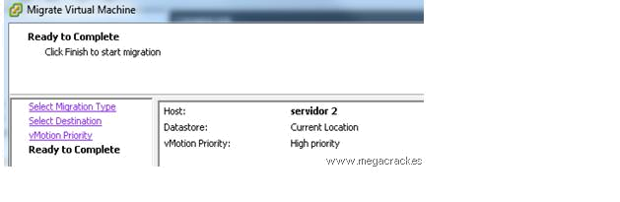

13) Click on Finish to start the migration

